AMD DISTRICT OF SURREY

Name……………………………………………………………………………………

Address…………………..……………………………………………………………..

………………………………………………………………………………….

Phone ......................................Mobile: ………………………………….

Email address.............................................................................

I will be attending the Hog Roast to be held at South West Surrey Masonic Centre, Guildford - on Sunday 14th July 2024
I enclose my cheque made payable to ‘District of Surrey’ AMD

………….….tickets

in the sum of £………….………… (£25.00 per person)

NAME OF GUEST(S): …………………… …………………………………………………….

……………………………………………………. ….………………………………………………….

…………………………………………………… ………………………………………………………

………………………………………………….. ………………………………………………………

………………………………………………….. ……………………………………………………….

N.B. Bank details below should you wish to transfer directly – please use your name as a reference and confirm the same to me, many thanks.
Bank:LLOYDS BANK
Account name: District of Surrey AMD
Account No: 00741683
Sort code: 30 90 44
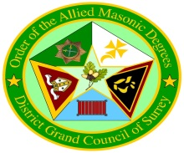HOG ROAST
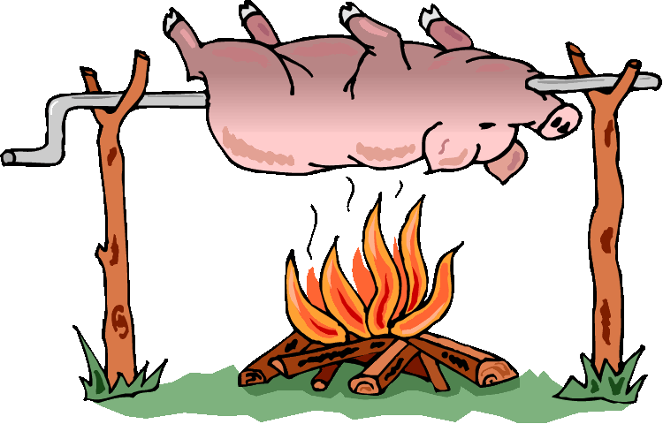
South West Surrey Masonic Centre
Hitherbury Close, Guildford GU2 3DR
01483 568768
Sunday 14th July 2024 (Midday for 1pm)
Drink on Arrival
HOG ROAST- £25.00
Various Salads - Choice of Sweets – Raffle
Tickets from: Kevin Brennan
26 The Street, Tongham, Farnham, Surrey. GU10 1DH
email: kevinbrennan33@gmail.com T:01252 658471 or M:07789 005336
A RAFFLE PRIZE WOULD BE APPRECIATED

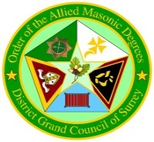AN INTRODUCTION TO THE ALLIED MASONIC DEGREES

In the order of the Allied Masonic Degrees of England and Wales and Districts and Councils Overseas, the District Grand Council of Surrey was Constituted at Croydon on Tuesday the 13th February 2007. This is under the supervision of the District Grand Prefect, R.W.Bro.John French, assisted by a dedicated team of District Officers drawn from the various Councils within his jurisdiction. Since that date the District has grown with the Consecration of three new Councils meeting at Nutfield, Guildford and Farnham. So how can this increase be explained?

The real charm of the Order is its variety. There are five degrees which can be worked. No meeting is therefore just the same as the one before. There are different officers and lectures for each degree, so every member has the opportunity to participate in the ceremonies if he so wishes and the participation can be large or small. The ceremonies are dramatic with much role playing and are enormous fun to perform. But underneath the fun and drama are serious Masonic lessons which cannot fail to enlighten the candidate.

The Degree of St Lawrence the Martyr must be taken first. It explains how Lawrence gave his life rather betray his principles and responsibilities. Integrity and fortitude are the lessons to be learned here. The other four degrees may be take in any order.

Knight of Constantinople concerns the relationship between the Emperor Constantine and his subjects. The ceremony is entertaining and amusing but at the end, the candidate is left in no doubt of the importance of humility.

Grand Tilers of Solomon is a very dramatic degree set in the secret vault beneath the Temple. It teaches us to reflect on the danger of hasty judgement.

Red Cross of Babylon covers the gap between the Craft and the Royal Arch, Zerubbabel obtaining permission to commence the rebuilding of the Temple. The lesson is the supreme importance of truth.

In the Order of Grand High Priest, which many believe should be the last degree to be taken. The candidate is anointed, consecrated and set apart to the service of God in the High Priesthood. This is a special and uplifting ceremony.
The Allied Masonic Degrees are open to brethren who
are Mark and Royal Arch Masons and of any faith.
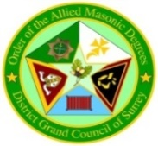
Dear Sir and Brother,

An invitation from the District Grand Prefect to attend the annual District Hog Roast - Please support this extravaganza and in doing so meet members of this and other Districts and enjoy a convivial luncheon in each other’s company; it is open to all members of our District, partners, family and friends (including children and non-masons)

This high-class event, which includes complimentary drinks on arrival, courtesy of R.W.Bro John French, District Grand Prefect, and an extensive range of food laid out buffet style in the restaurant. It is our usual custom to hold a raffle (please if you can bring a prize).

Delight in the pleasant surroundings of the Guildford Masonic Centre, Weybourne House, Hitherbury Close, Guildford, Surrey GU2 4DR;

Please complete the attached booking form returning it to me ASAP to my home address 26 The Street Tongham Farnham Surrey GU10 1DH (including a cheque!), alternatively, should you prefer, please pay by transfer, and confirm your booking and payment details via email.

Thank you in anticipation for your support and I look forward to greeting you.
Kindest regards
Bro Kevin Brennan Riverside Council No 212
For bookings please contact: Kevin Brennan
26 The Street Tongham Farnham Surrey GU10 1DH
email: kevinbrennan33@gmail.com
T:01252 658471or M:07789 0005336

